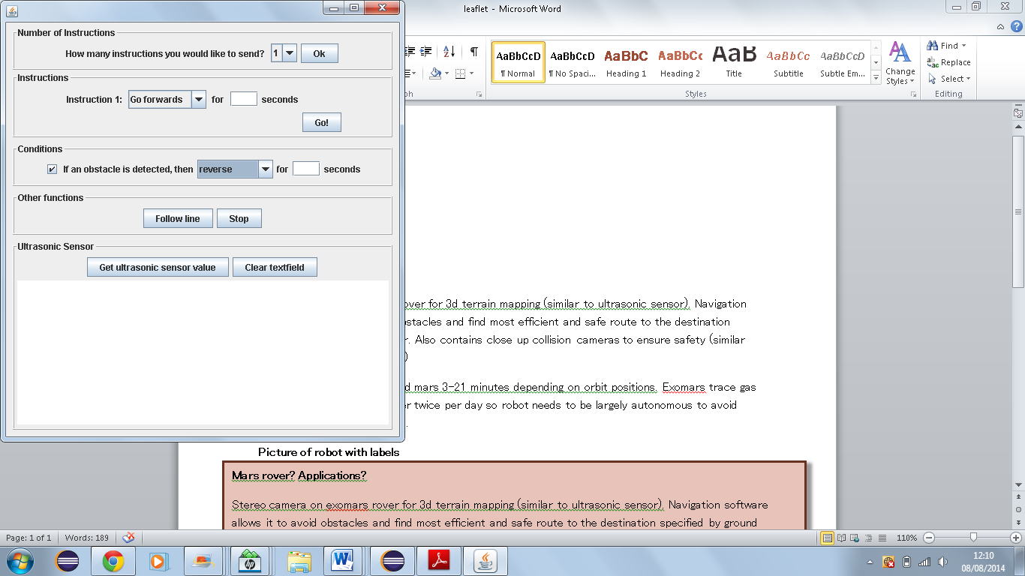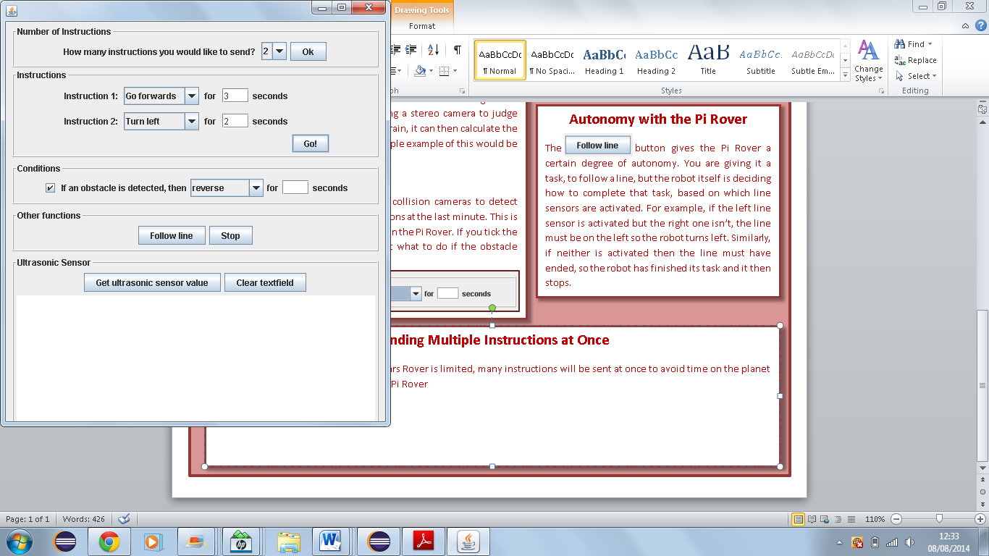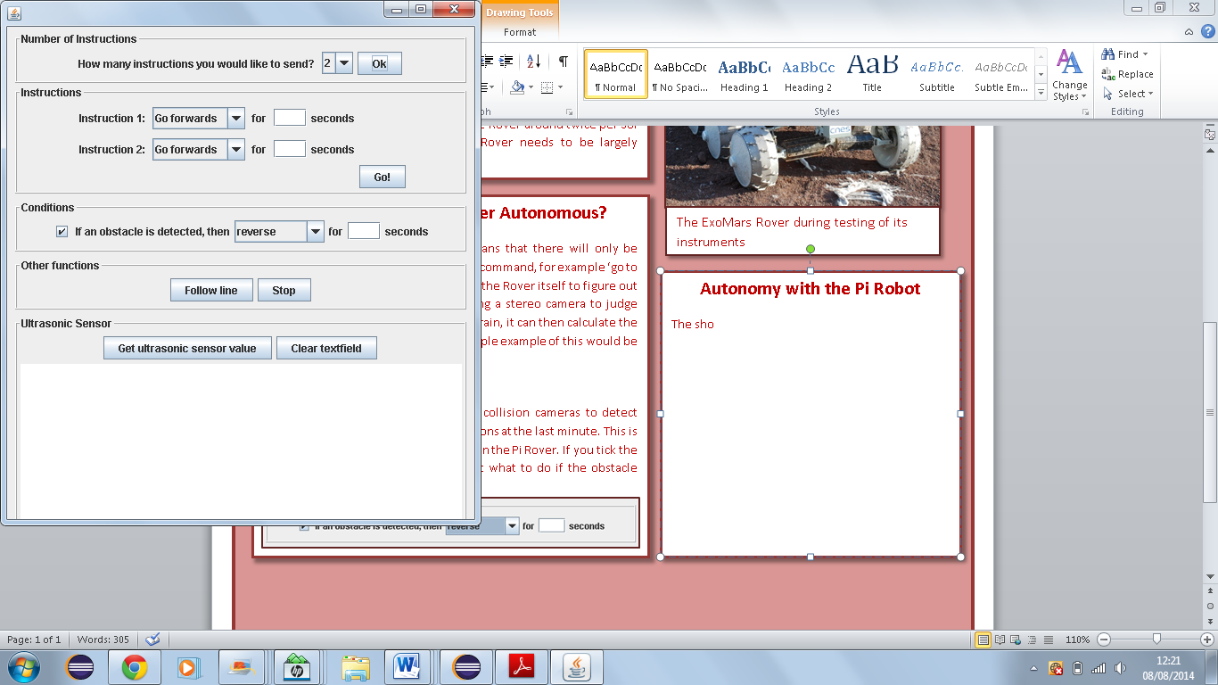

Because communication with the ExoMars Rover is limited, many instructions will be sent at once to avoid time on the planet being wasted. You can do something similar to this using the Pi Rover. Just choose how many instructions you would like to send, press Ok, customise them, and then press Go.

**Sending Multiple Instructions at Once**

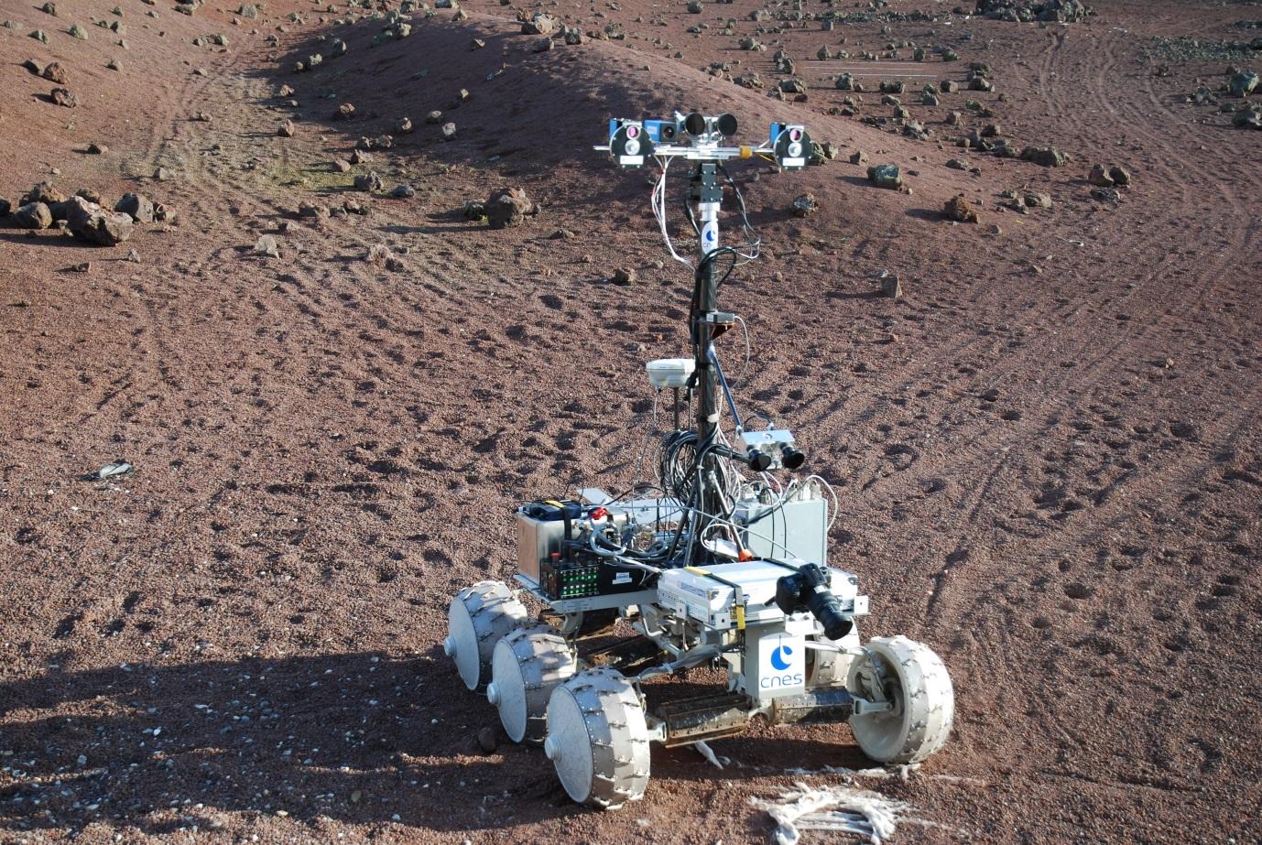

The ExoMars Rover during testing of its instruments

**Autonomy with the Pi Rover**

The button gives the Pi Rover a certain degree of autonomy. You are giving it a task, to follow a line, but the robot itself is deciding how to complete that task, based on which line sensors are activated. For example, if the left line sensor is activated but the right one isn’t, the line must be on the left so the robot turns left. Similarly, if neither is activated then the line must have ended, so the robot has finished its task and it then stops.

**How is the ExoMars Rover Autonomous?**

The short communication window means that there will only be enough time to send the Rover a simple command, for example ‘go to a certain set of coordinates’. It is up to the Rover itself to figure out how to get there. It does this by using a stereo camera to judge distance and create a 3D map of the terrain. It can then calculate the most safe and efficient route. A very simple example of this would be the ultrasonic sensor on the Pi Rover!

**Object Avoidance** The ExoMars Rover also has close up collision cameras to detect objects and avoid any unexpected collisions at the last minute. This is similar to the infrared obstacle sensors on the Pi Rover. If you tick the box you can customise a rule to tell it what to do if the obstacle sensors are activated!

**What is the ExoMars Rover?**

**Mission** The ExoMars Rover is due to be launched in 2018 by the European Space Agency and it has two main goals: to test technologies that will be required for future missions to Mars, such as gathering and returning geological samples to Earth, and to investigate the chemical composition of the planet and its atmosphere to study its history. **Communication** In 2016 the Trace Gas Orbiter will be launched which, in addition to analysing Mars’ atmosphere, will have the important task of allowing communication between the Rover and Earth. Light takes between 3 and 21 minutes to travel between the Earth and Mars, so controlling the Rover directly would be extremely difficult. To make things worse, the Orbiter only passes over the Rover around twice per Sol (Martian day). Because of this, the Rover needs to be largely **autonomous.**

ExoMars Rover